Steps – Route 53 Assignment

Questions

Amazon Web Services (AWS) Route 53 Overview

Groupe of Gladys

1. Jean-Pierre GBEDJISSI
2. Gladys Aba Kwofie
3. Augustine Gideon
4. Segla Enagnon Ulrich

Amazon Route 53 is a scalable and highly available Domain Name System (DNS) web service offered by Amazon Web Services. It is designed to provide efficient and reliable domain registration, DNS routing, traffic management, health checks, failover, and DNS security services. Route 53 is a crucial component for building and managing scalable and fault-tolerant applications and services on AWS. Let's explore its key features and common use cases.

Key Features:

Domain Registration: Route 53 allows you to register new domain names or transfer existing ones. It simplifies the process of managing domain registrations within the AWS ecosystem.

DNS Routing: Route 53 is a high-performance and scalable DNS web service that translates user-friendly domain names into IP addresses, allowing users to access resources on the internet.

Traffic Management: Route 53 provides intelligent traffic routing capabilities, allowing you to distribute incoming traffic across multiple AWS resources based on various routing strategies.

Health Checks and Failover: You can configure Route 53 to perform health checks on your resources and automatically route traffic away from unhealthy resources to healthy ones. This is vital for ensuring high availability and fault tolerance.

DNS Security: Route 53 offers DNS security features such as DNSSEC (DNS Security Extensions) to protect against DNS-related attacks and ensure data integrity.

Common Use Cases:

Hosting Websites: Route 53 is commonly used to route traffic to web servers hosted on AWS, making websites highly available and scalable.

Load Balancing Traffic: It supports load balancing of traffic across multiple AWS resources, such as Amazon EC2 instances or AWS Elastic Load Balancers, ensuring even distribution and fault tolerance.

Disaster Recovery: Route 53 can help in disaster recovery scenarios by routing traffic to a secondary AWS region in the event of a primary region failure.

Global Content Delivery: It enables global content delivery by using latency-based routing to direct users to the nearest AWS resource, reducing latency and improving user experience.

Routing Based on Health Checks: Route 53 performs health checks and routes traffic to healthy resources, ensuring continuous service availability.

Managing Domain Names: Route 53 simplifies domain management tasks like registration, DNS configuration, and renewal.

DNS Routing Strategies:

Simple Routing: Directs traffic to a single resource, typically used for non-complex routing requirements.

Weighted Routing: Allows traffic to be distributed based on assigned weights, making it suitable for A/B testing or gradually rolling out updates.

Latency-Based Routing: Routes traffic based on the lowest network latency to improve user experience.

Geolocation-Based Routing: Routes traffic based on the geographic location of the user, enabling content localization and geo-targeting.

Multi-Value Routing: Returns multiple IP addresses for a DNS query, useful for load balancing and fault tolerance.

Failover Routing: Automatically routes traffic to a standby resource in the event of a primary resource failure, ensuring high availability.

Demo:

Hosting a Website on AWS using Amazon S3 and Route 53 involves setting up a custom domain with Route 53, configuring an S3 bucket for website hosting, and creating appropriate DNS records in Route 53 to direct traffic to your S3-hosted website. This setup provides a cost-effective and scalable way to host personal or business websites on AWS while ensuring high availability and reliability.

Here is the diagram of the system:

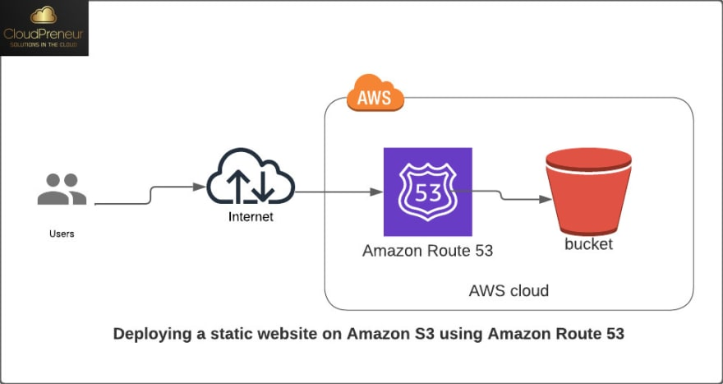

We follow the following steps:

1. Register the domain name

Image 1 to 8

* Inside the AWS console, choose Route 53 service
* Click on register domain
* Type the root domain wanted and click on search to check its availability
* Once decided of the price, availability and name, click on select to go to the next page
* Input your contact information and the mail you want it to be linked to the domain
* Review the information entered

Before you click on submit make sure you have enough cash on your card linked to your AWS account to avoid been debited again when you have it

It may take some minutes for the domain to be available

* Accept the mail sent to the email provided talking of your agreement to this domain registration
* And some in a while the domain should be successful inside request of Route 53

1. Create a bucket, enable website hosting and upload the website

Image 9 to 16

1. Create a second bucket for the subdomain redirection

Image 17 - 18

1. Add some records to the hosted zone generated

Image 18 – 23

Our domain www.jeanpierrecaleb.link is displaying our website

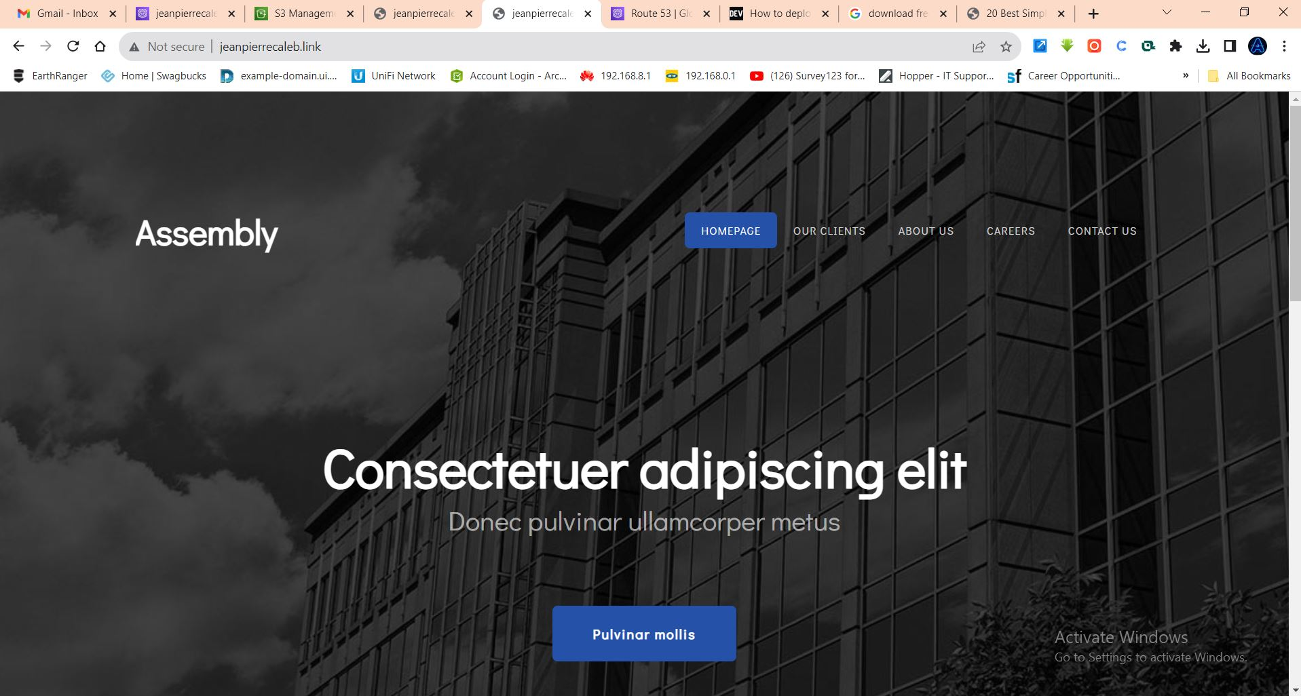

In summary, Amazon Route 53 is a versatile DNS and traffic management service that plays a critical role in ensuring the availability, scalability, and security of applications and services hosted on AWS. Its features and routing strategies make it an essential tool for managing domain names and routing traffic effectively across AWS resources.